**INSTRUCTIONS FOR USE**

**Disposable Monopolar Scissor**

**IMPORTANT INFORMATION – PLEASE READ BEFORE USE!**

Please read all information contained in this insert. The use of an instrument for a task other than that for which it is intended, incorrect handling, improper care, failure to adhere to all warning and precautions and misuse can lead to premature wear and/or have serious clinical consequences to the user or patient, such as injury, contamination, cross-infection, or death. Federal (USA) law restricts this device to sale by or on the order of a physician.

Before using, read the following information thoroughly. This booklet is designed to assist in using this product. It is not a reference to surgical techniques.

**INTENDED USE:** The **PMI LAP**SYSTEM™ Disposable Monopolar Scissor is designed to cut, dissect, and cauterize various tissues during laparoscopic procedures.

**INSTRUCTIONS FOR USE:**

1. Using sterile technique, remove the unit from the packaging.
2. Fully inspect the unit and packaging for any damage.
3. Connect the monopolar cable to the RF post and ensure a full connection prior to use.
4. Discard after use.
5. RF Post

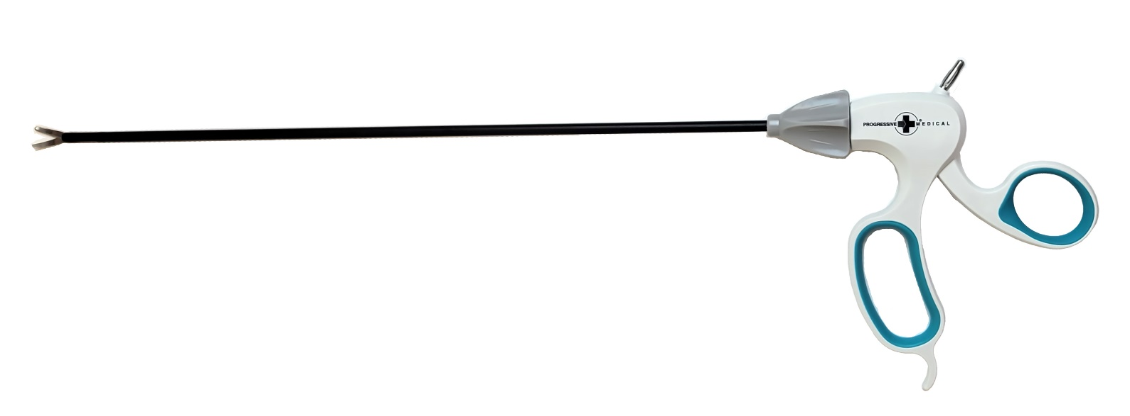

**A**

**B**

**C**

1. Shaft Rotation Knob
2. Scissor Tip

**PRECAUTIONS AND WARNINGS:**

* Do not use if the sterile package is opened or damaged.
* This device is designed for single use only and should not be reused or re-sterilized.
* Confirm compatibility of the electrosurgical generator, monopolar cable, and **PMI** **LAP**SYSTEM™ Disposable Scissor prior to use.
* Procedures should be performed only by physicians with training in laparoscopic procedures and anatomy. Additionally, medical literature should be consulted regarding techniques, hazards, contraindications, and potential complications prior to beginning these procedures.

**SINGLE USE PRECAUTION:**

This device is designed and sold for single use only and should not be reused. Re-sterilization/ reprocessing is not approved. The effects of re-sterilization/reprocessing can result in the following complications:

* Cross-contamination due to ineffective re-sterilization/reprocessing.
* Mechanical fatigue and failure due to the effects of re-sterilization/reprocessing.

**SYMBOLS**

|  |  |  |  |
| --- | --- | --- | --- |
|  | Caution |  | Consult Instructions for Use |
|  | Catalog Number | Rx ONLY | Authorized for sale or use by physician only |
|  | Expiration Date |  | Manufacture Date |
|  | Lot Number |  | Sterilized by Ethylene Oxide (EO) |
|  | Single Patient User Only |  | Do Not Re-Sterilize |
|  | Do Not Use if Package is Damaged | A grid of white squares  Description automatically generated  Intentionally left blank | |